CO3-AT3 – Visualization Critique & Redesign

Question 1 – Critique and Redesign an ECDF and Q-Q Plot

Visualization Issues

  - The axis labels are not sufficiently descriptive to clearly show salary ranges and cumulative probabilities.
  - Inappropriate scaling can make differences between salary values less noticeable.
  - Too many colors, visual elements, and grid lines can reduce readability and distract from the main information.
  - Without a reference line, the Q-Q plot becomes less effective for evaluating whether the data follows a normal distribution.

Interpretation

The improved ECDF indicates that employee salaries are mainly distributed within the ₹38,000–
₹58,000 range. However, the ₹72,000 salary is considerably higher than the majority of the observations. This could indicate a positively skewed distribution and may represent a potential outlier.

The Q-Q plot shows that observations lying near the reference line generally follow a normal distribution. Any noticeable deviation, particularly at the higher salary levels, indicates that the data may have some departure from normality.

Is a Q-Q Plot Sufficient?

A Q-Q plot alone is not sufficient to confirm normality. It should be combined with additional techniques such as a histogram, descriptive statistics, or the Shapiro-Wilk test. Using multiple methods provides stronger evidence for determining the actual distribution of the salary data.

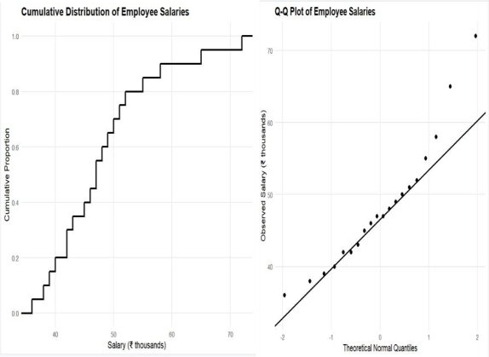
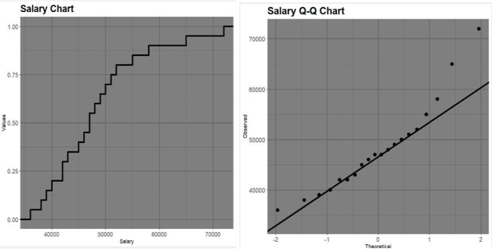

Question 2 – Critique and Redesign Many Distributions Using Bean Plots

Problems with separate histograms

  - Different bin widths can make distributions look artificially different.
  - Different scales make direct comparison difficult.
  - Separate plots require more effort to compare.
  - Histograms may hide individual score patterns.

Interpretation

Using a common scale in a bean or violin plot makes comparison easier. The plot shows where scores are concentrated and how widely they are distributed.DataViz has the greatest spread, ranging from 55 to 84 (range = 29). The course with the highest concentration can be identified by the widest or densest part of the bean/violin plot.
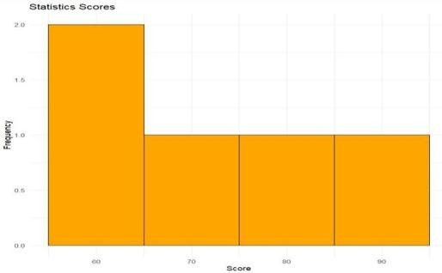
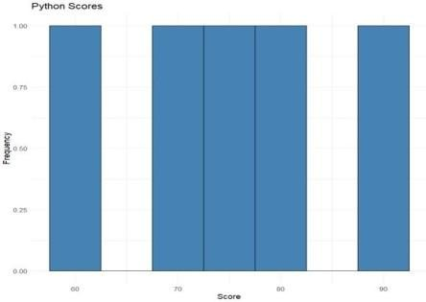

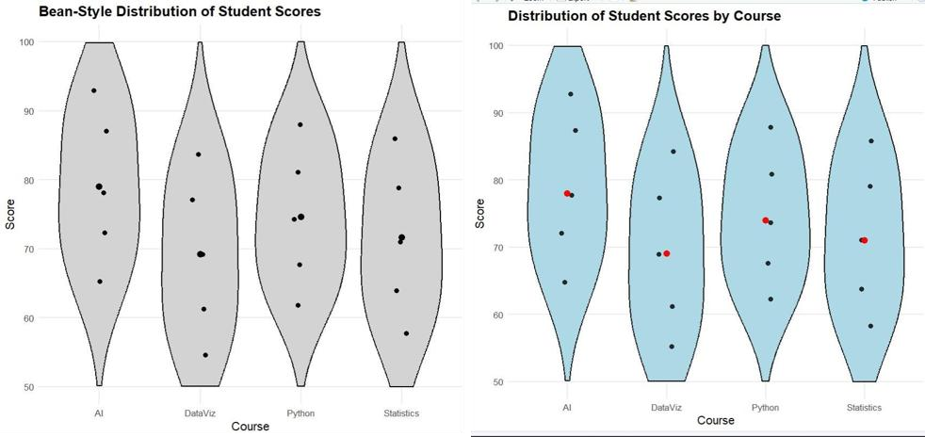

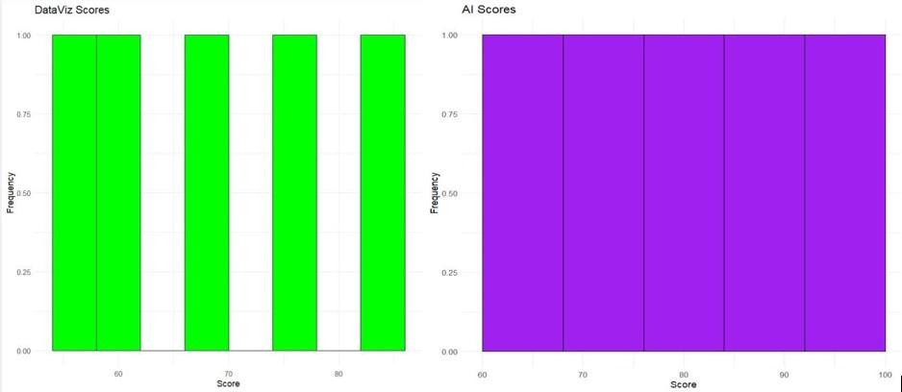

Question 3 – Critique and Redesign Proportion Visualizations

Problems with pie charts

  - Different starting angles make comparisons difficult.
  - 3-D effects distort the apparent size of slices.
  - Inconsistent labels can confuse users.
  - Comparing proportions across separate pie charts is difficult.

Comparison of redesigns
A side-by-side bar chart is better for comparing the actual number of purchases between regions. A 100% stacked bar chart is better for comparing product proportions because every region uses the same 100% scale.

Why are 3-D effects misleading?

3-D effects can make some slices appear larger because of perspective. Inconsistent scales can also exaggerate or hide differences. Flat charts with common scales provide a more accurate comparison.
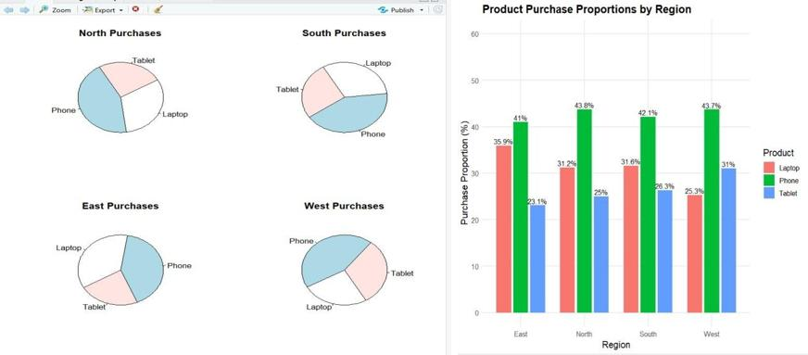

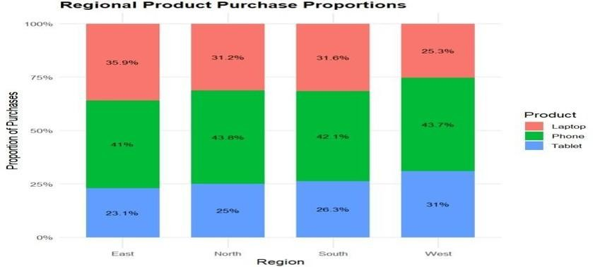

Question 4 – Critique and Redesign Nested Proportions

Problems with the original treemap

  - Small rectangles have unreadable labels.
  - The hierarchy between Region, Category, and Subcategory may not be clear.
  - Similar or unclear colors can cause confusion.
  - Comparing small areas is difficult.

Treemap vs Sunburst

A treemap uses area to represent sales and is useful for quickly identifying large and small categories. A sunburst chart shows the hierarchical structure more clearly using rings, but comparing segment sizes can be more difficult.

Recommendation

For a management presentation, the redesigned treemap is recommended because it allows managers to quickly identify the largest regions, categories, and subcategories.

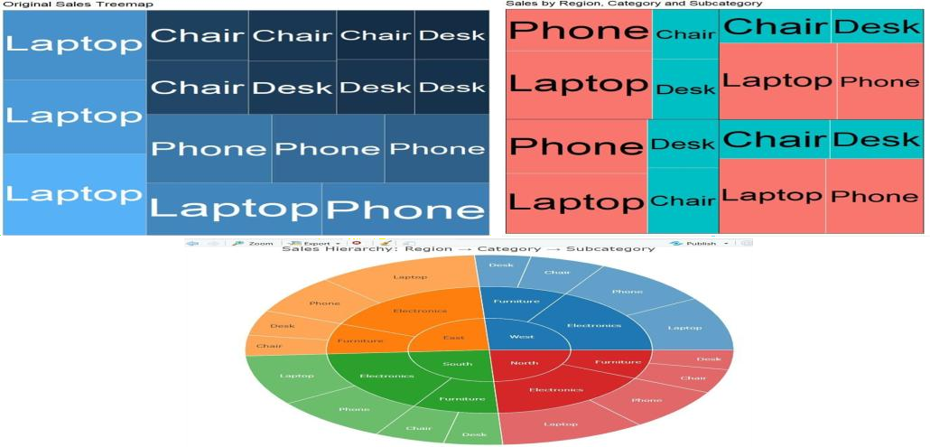

Question 5 – Critique and Redesign Flow-Based Proportions

Problems with the original Sankey diagram

  - Similar colors make flows difficult to distinguish.
  - Unlabelled flows make exact values unclear.
  - Overlapping flows can create confusion.
  - The hierarchy between stages may not be visually clear.

Interpretation

The redesigned Sankey diagram uses clear labels, consistent colors, and flow widths based on the number of students.
It shows that IT is the major placement sector. The largest individual flow is:

AI → Internship Yes → IT = 20 students

3 & 4. Sankey vs Parallel Sets

A Sankey diagram clearly highlights major flows using flow width. A parallel sets plot is useful for comparing categorical relationships but can become difficult to follow with many categories. Therefore, the Sankey diagram is recommended because it makes the largest student pathways easier to identify.
